|  |  |
| --- | --- |
| **BHAGWAN PARSHURAM INSTITUTE OF TECHNOLOGY, GGSIPU** | |
| NAME | SARTHAK DUA |
| BRANCH AND BATCH | CSE, 2018 - 2022 |
| ENROLLMENT NO | 06520802718 |

For the role of Front End Developer at Josh Technologies.

**Key Features of the Website**

1. Fully Responsive, **Mobile Responsive** (doesn’t break on different viewport sizes).
2. Pixel Perfect Website.
3. Comments have been added to the code for easy understanding of code.
4. A working carousel **is** implemented without external sources.
5. Other salient features like adding active classes , dropdown menu are added using JavaScript.
6. **No** use of UI Framework like Bootstrap or Material UI .
7. Website is implemented purely with HTML, CSS & JS.

* **Here is how the website looks on Mobile / Tablet Devices.**

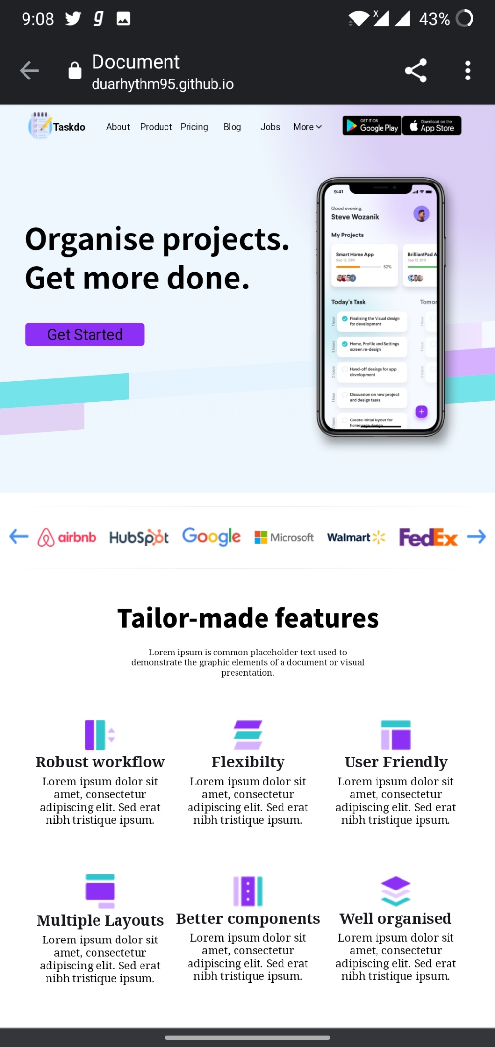



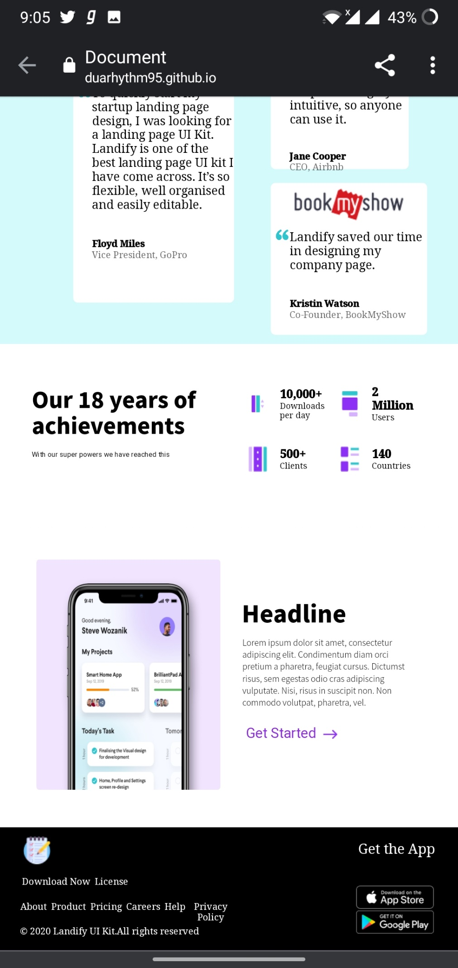

* **Here is how the website looks on Laptop Devices**



